IOT assignment 02-07-2026
IoT Summer School 2026 Author: SATYAM KUMAR
Answers to the IoT design and problem-solving questions.

Q1.You are building a smart irrigation system that must monitor soil moisture, control a water pump, and send data to a mobile application every 5 seconds. You have both an Arduino UNO and an ESP32. Which controller would you choose and why? Would your answer change if internet connectivity was not required?
For a smart irrigation system that must send data to a mobile app every 5 seconds, I would choose the ESP32. The reason is that the ESP32 has built-in WiFi and Bluetooth, so it can connect to the internet and send data to the app on its own. The Arduino UNO has no wireless, so it would need an extra WiFi module to do the same job. The ESP32 is also faster and has more memory, which helps when handling sensor data and networking together.
My answer would change if internet connectivity was not required. If the system only had to read the soil moisture and control the pump locally, without sending data anywhere, then the Arduino UNO would be enough and cheaper. So the choice really depends on whether the internet part is needed.

Q2. A smart factory contains 500 sensors distributed across a 2 km area. Compare Wi-Fi, Bluetooth, LoRa, and MQTT-based communication. Which protocol or combination of protocols would you choose and why?
For 500 sensors spread across a 2 km area, the main challenge is the long distance and the large number of devices. WiFi and Bluetooth have a short range only a few metres to tens of metres, so they cannot cover 2 km. LoRa is designed for long range and low power, so it can easily reach across 2 km, which makes it the best fit for sending sensor data over that distance.
MQTT is not really a competing option here, it is a messaging protocol that works on top of a network, not a radio like the others. So the best solution is a combination: use LoRa to carry the data over the long distance to a central gateway, and then use MQTT (over WiFi or internet) at the gateway to publish the data to a server. This way LoRa handles the range and MQTT handles the organised delivery.

Q3. A temperature sensor suddenly starts showing impossible values (e.g., –120°C or 300°C). How you would determine whether the problem lies in the sensor, wiring, power supply, ADC, or software.
If a temperature sensor suddenly shows impossible values like -120 or 300, I would check the possible causes one by one instead of guessing. First I would check the wiring, because a loose or swapped wire is the most common cause ,I actually saw this myself when a swapped VCC and data pin gave wrong readings. Next I would check the power supply, since low or unstable voltage can make a sensor give random values.
After that I would check the sensor itself by testing it with a simple known example or swapping it with another sensor to see if the problem follows the sensor. Then the ADC, by reading the raw value to see if it is stuck or jumping. Finally I would check the software, to make sure the formula converting the reading to temperature is correct. Checking in this order helps find where the problem really is.

Q4. An ESP32-based weather station must operate on battery power for six months without maintenance. What hardware and software modifications would you make to maximize battery life?
To make an ESP32 weather station run for six months on battery, the biggest thing to fix is power usage, because the ESP32 uses a lot of power when WiFi is always on. On the hardware side, I would use a large battery, add a solar panel if possible, and remove any parts that waste power like extra LEDs or voltage regulators that are not needed.
On the software side, the main change is using deep sleep. Instead of staying on all the time, the ESP32 would wake up, take a reading, send it, and then go back to deep sleep, which uses almost no power. I would also make it send data less often (for example every few minutes instead of every second) and only turn on WiFi when it actually needs to send. These changes together can make the battery last much longer.

Q5. An automatic braking system in a vehicle requires communication with almost zero delay. Which communication method would you choose and why?
An automatic braking system needs communication with almost zero delay, because even a small delay could cause an accident. For this I would choose a wired protocol like CAN bus, which is used in vehicles for exactly this reason. Wired communication is much faster and more reliable than wireless, since there is no signal drop or interference.
Wireless options like WiFi or Bluetooth would be a bad choice here because they can have delays, lose connection, or face interference, which is dangerous for safety systems. So for something as critical as braking, a fast and dependable wired connection is the right choice.

Q6. You need to measure the average temperature of a classroom using only one sensor. Where would you place the sensor and why? Explain how poor placement could affect the accuracy of your measurements. Assume the classroom to be a square-base cuboid of side length “a” and height “b”.
To measure the average temperature of a classroom with only one sensor, placement matters a lot. I would place the sensor near the centre of the room, at about mid-height (roughly half of height b), away from walls, windows, doors, and the ceiling. The centre gives the most balanced reading because it is not affected by any single hot or cold spot.
Poor placement would make the reading inaccurate. For example, if the sensor is near a window it would read the outside temperature, near a door it would catch draughts, near the ceiling it would read warmer air (since hot air rises), and near an AC or fan it would read too cold. Since the room is a square-base cuboid of side a and height b, the best single point is around the middle, at roughly (a/2, a/2, b/2), so it represents the room as a whole.

Q7. Under what situations could an analog sensor perform better than a digital one?
An analog sensor can be better than a digital one when you need to measure a smooth, continuous range of values rather than just steps. Analog sensors give a value that changes continuously, so they can capture small changes very finely, which is useful for things like light level, temperature, or sound where the exact amount matters.
They can also be better when you need a fast response and simple circuit, since an analog sensor sends its value directly without needing to process it into digital form first. For example, an LDR (analog) gives a smooth light reading that I can compare against any threshold I want, which gives more control than a sensor that only says "bright" or "dark".

Q8.Draw the complete architecture/block diagram of your IoT project, beginning from the sensor and ending at the user interface. Identify every possible point where a failure could occur and suggest one solution for each.
The architecture of my IoT project goes step by step from the sensor to the user:
Sensor → Microcontroller (ESP32) → Network (WiFi/MQTT) → Cloud/Server → User Interface (app or dashboard).
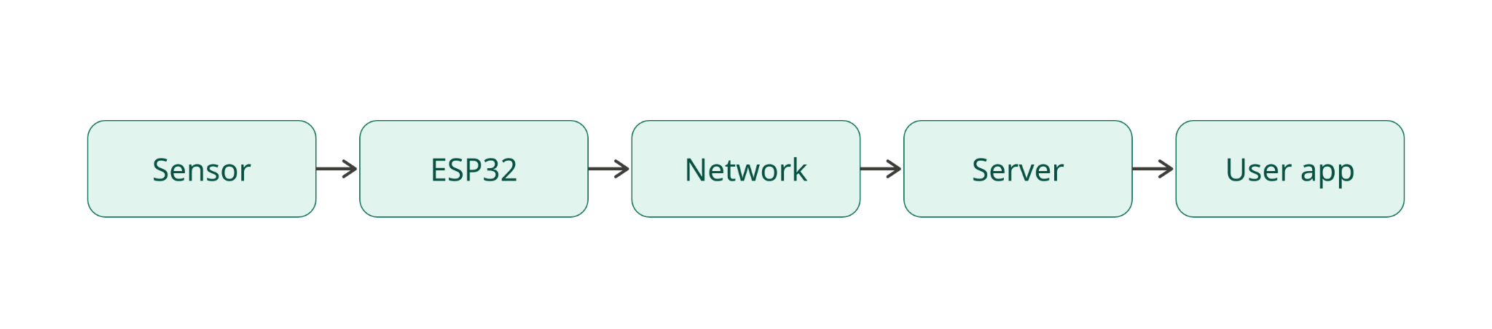
Failure points and one solution for each:
- Sensor fails or gives wrong data → add a check in code to ignore impossible values, or use a backup sensor.
- Wiring/connection loose → use secure connections and check readings regularly.
- Microcontroller crashes → use a watchdog timer to restart it automatically.
- Network/WiFi drops → store data locally and upload later when the connection returns.
- Cloud/server down → keep a local copy of data so nothing is lost.
- User interface not updating → add auto-refresh and show the last known value with a timestamp.

Q9. If an attacker gains access to your IoT device through the Wi-Fi network, what kinds of attacks could they perform? Suggest at least five methods to improve the security of the system (with applicable solutions, do not cite far-fetched ideas)
If an attacker gets into my IoT device through the WiFi network, they could do several harmful things: read or steal the sensor data, send fake commands to control the device, change the settings, use the device to attack other devices, or shut the system down.
Five ways to improve the security:
- Use a strong WiFi password and change the default one, so it is hard to break in.
- Use encryption (like HTTPS or TLS) so the data cannot be read even if it is captured.
- Add authentication, so only allowed users can send commands to the device.
- Keep the firmware updated, so known security holes are fixed.
- Do not store passwords or keys in the code that gets uploaded (I kept my config.h in gitignore for this reason).

Q10. Your ESP32 must simultaneously interface with a DHT11 sensor, an ultrasonic sensor, an OLED display, a relay module, and a soil moisture sensor. What hardware or software conflicts could occur, and how would you solve them?
If an ESP32 has to work with a DHT11, an ultrasonic sensor, an OLED display, a relay, and a soil moisture sensor at the same time, some conflicts can happen. There can be not enough pins, or two devices trying to use the same pin. The OLED usually uses I2C (SDA and SCL), and if another device needs the same pins there is a clash. There can also be power problems, since powering many devices from the ESP32 can pull too much current, and timing problems if reading one sensor blocks the others.
To solve these: plan the pins carefully so each device has its own pin, use I2C for devices that support it (since I2C shares just two pins for many devices), power heavier parts like the relay from a separate supply instead of the ESP32, and use non-blocking code with millis() so reading one sensor does not freeze the others.

Q11. An ESP32 uploads sensor data to the cloud every minute. The internet connection fails for 12 hours. Design a strategy that ensures no important data is permanently lost.
If the internet connection fails for 12 hours while the ESP32 is uploading data every minute, the goal is to not permanently lose any important data. The strategy is to store the data locally whenever the internet is down. The ESP32 can save readings to its flash memory or an SD card, along with the time of each reading.
When the connection comes back, the device checks its stored data and uploads all the saved readings that were missed, then continues normally. To avoid running out of storage during a long outage, it can save data less often or only save important changes. This way, even a 12 hour outage does not lose the data, it just gets uploaded later.

Q12. Your IoT device must operate continuously for five years without human intervention. What changes would you make to both the hardware and software to improve long-term reliability?
For a device that must run for five years without anyone touching it, reliability is the most important thing. On the hardware side, I would use good quality parts, protect the device from dust and moisture with a proper case, use a reliable power source (like solar with a battery), and avoid parts that wear out quickly.
On the software side, I would add a watchdog timer that restarts the device automatically if it freezes, make the code handle errors instead of crashing, and allow over-the-air (OTA) updates so the software can be fixed remotely without physically reaching the device. I would also make it save its data safely so a restart does not lose anything. These steps help it keep running for years on its own.

Q13. Can an IoT system be considered "smart" if it does not use Artificial Intelligence? Justify your answer with suitable examples. What differentiates “smart” from “intelligent”?
Yes, an IoT system can still be called smart without using Artificial Intelligence. "Smart" usually means the system can sense its surroundings and react automatically using simple rules, without a person controlling it. For example, my smart street light turns on when it is dark and there is motion, and my relay system turns on a fan when it gets too hot. These are smart because they act on their own, but they do not use AI.
The difference is that smart means following set rules to react to conditions, while intelligent means the system can actually learn from data and improve or make decisions on its own using AI. So a smart system reacts, but an intelligent system learns. Most everyday IoT devices are smart, not truly intelligent.

Q14. Compare polling and interrupt-based programming in embedded systems. In which situations would interrupts significantly improve the performance of an IoT device?
Polling means the program keeps checking a sensor or button over and over in the loop to see if something changed. It is simple, but it wastes time checking even when nothing is happening, and it can miss a fast event if the program is busy doing something else.
Interrupt-based programming means the device only reacts when an event actually happens, instead of constantly checking. An interrupt "pauses" the normal code the moment something occurs and runs a special piece of code. Interrupts significantly improve performance when an event is rare or must not be missed, like counting fast pulses, waking the device from sleep, or catching a button press exactly when it happens. This saves power and makes the device more responsive.

Q15. Every engineering design involves trade-offs. Looking at your own IoT project, identify three design decisions where you sacrificed one aspect (such as cost, speed, power, accuracy, or complexity) to improve another. Explain whether you believe those trade-offs were justified.
Every design has trade-offs, and I made a few in my own work:
- Simulator vs real hardware (accuracy vs speed): I built many programs in TinkerCAD and Wokwi instead of real hardware. This was faster and easier, but it is less realistic than building everything physically. I think this trade-off was justified because of the time limit, and I still did the wireless parts on real hardware.
- 150 ohm vs ideal resistor (simplicity vs perfection): I used the resistors I had available even though they were not the textbook value for every LED. It made the LEDs slightly brighter, but it worked fine and saved time. This was justified because it did not harm anything and the demo still worked.
- Multiplexed matrix vs 16 separate pins (efficiency vs simplicity): For the LED matrix I used a multiplexed design (8 pins for 16 LEDs), which saves pins but looks dimmer in simulation. I chose it because it is the proper real-world method, even though a simpler 16-pin version would have looked brighter. I think this was justified because it taught me how real matrices work.

Q16. Create a flowchart for an IoT system that stores sensor readings locally whenever Wi-Fi is unavailable and automatically uploads the stored data once the connection is restored. Mention all the programs/protocols/I-O used in the system.
The system works like this in steps:
Start → Read sensor → Is WiFi available? →
- If YES: upload the reading to the server, then continue.
- If NO: save the reading in local storage (flash or SD card), then continue. → When WiFi comes back, upload all the saved readings, then delete them from storage → Repeat.
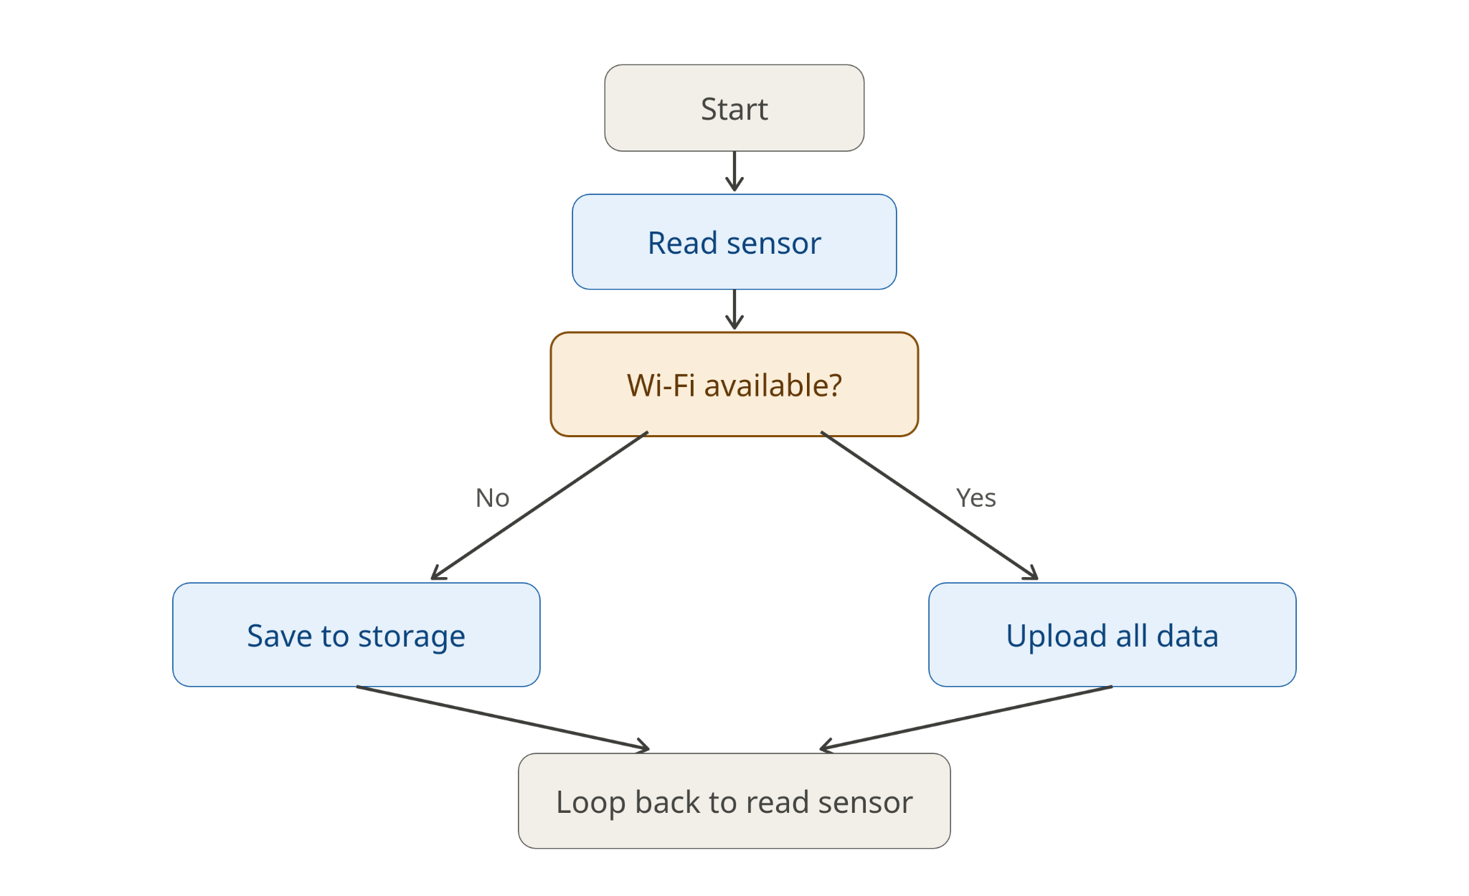
Programs / protocols / I-O used: sensor input (I-O), the ESP32 for processing, WiFi and MQTT or HTTP for uploading, and local flash/SD storage for saving data when offline.

Q17. Draw a flowchart showing how an ESP32 performs an OTA (Over-the-Air) firmware update, including error handling if the update fails.
The steps for an Over-the-Air firmware update are:
Start → Device checks the server for a new firmware version → Is a new version available? →
- If NO: keep running the current firmware.
- If YES: download the new firmware → Was the download successful and valid? →
  - If YES: install the update and restart the device with the new firmware.
  - If NO (download failed or file corrupted): cancel the update, keep the old firmware running, and try again later.
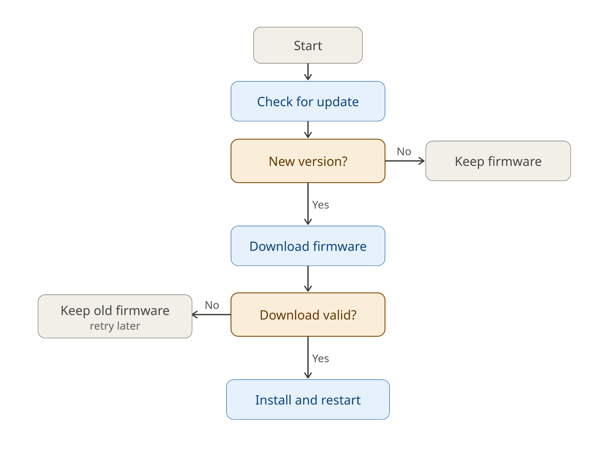
The error handling is important so that if the update fails, the device does not get stuck or break, it simply keeps the working old version and tries again.

